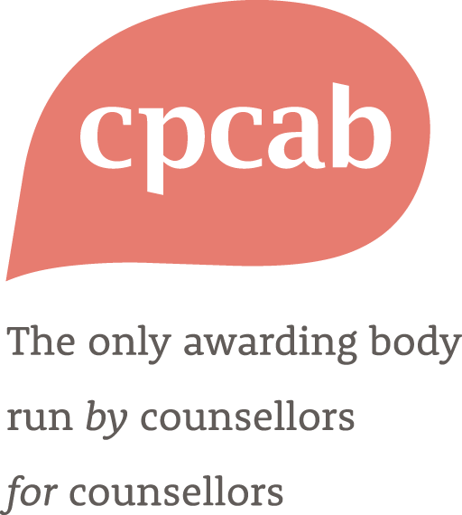
2025-2026
Specification
Level 5 Diploma in Psychotherapeutic Counselling (PC-L5)

This RQF qualification is regulated by Ofqual in England, Qualifications Wales in Wales and CCEA in Northern Ireland.
Qualification/learning aim number: 500/8386/7
Sector subject area: 1.3 Health and Social Care

Counselling & Psychotherapy Central Awarding Body (CPCAB)
P.O. Box 1768
Glastonbury
Somerset
BA6 8YP
Tel. 01458 850 350
Website: www.cpcab.co.uk
Email: contact@cpcab.co.uk



____________________________________________________________________________________
Please note:
This document, along with candidate support materials, can be downloaded from the CPCAB website. If you need help with the accessibility of this document, please email contact@cpcab.co.uk with your request.
_____________________________________________________________________________________

Contents | Page
- Qualification Information | 3
- Qualification Summary | 6
- Minimum Assessment Requirements | 8
- Tutor-Assessor Qualifications and Experience | 9
- Candidate Entry Requirements | 10
- Fit for Purpose | 11
- Progression Routes | 12
Find us on Facebook
Follow us on LinkedIn
Watch us at CPCAB Videos
Discover new & interesting things at the CPCAB Hub

- Qualification Information

Purpose Statement | This qualification is designed to give learners the knowledge, skills and competencies to work as self-employed counsellors in independent practice. It also equips learners to take on a senior counselling role in an organisational context where client assessment, referral and routine evaluation are part of the role.  This qualification will enable successful candidates to work as counsellors in a range of job and career opportunities, which include but are not limited to:  - An autonomous counsellor in private practice or agency settings.  - Work as a senior counsellor within a counselling agency.  - The graduate may choose to diversify into the area of teaching counselling within a FE or HE context providing they hold suitable teaching experience or qualifications.
Funding | The qualification is eligible in England for Advanced Learner Loans (19+)  The link to the government website which provides details of funding for this qualification can be found here:
Level | 5
Guided Learning Hours (GLH) | 120 (minimum)
Total Qualification Time (TQT) | 458
Credit value | 46
Minimum Age | 19 years. Please see CPCAB Candidate Entry Requirements .
Entry Requirements | CPCAB Level 4 Diploma in Therapeutic Counselling (TC-L4) or an equivalent qualification (minimum 420 Guided Learning Hours), in addition to appropriate pre-TC-L4 (or equivalent) training.  Please see:  - CPCAB Candidate Entry Requirements for criteria considered important in selecting applicants for a programme leading to PC-L5.  - CPCAB’s Policy on Recognition of Prior Learning (RPL) and Entry Requirements.
Assessment | Proficient (Pass)/Not Proficient (Fail)  Candidates must be Proficient in internal assessment and meet all the qualification requirements including all placement hours to achieve the qualification.  Internal assessment: tutor assessment of candidate portfolio evidencing minimum assessment requirements and verified by CPCAB.  See CPCAB’s Minimum Assessment Requirements.
Additional Qualification Requirements | Personal counselling: a minimum of 40 hours of personal counselling by the end of the course. This can include hours undertaken prior to the start of the course but at least 10 hours of personal therapy must be undertaken during the training year itself.  Client work: a minimum of 60 hours formally contracted counselling (one-to-one), including client assessment.  Clinical Supervision: either group or one-to-one supervision – as per the supervision ratio requirements of their chosen ethical framework or professional membership association.
Staffing and Resources | At least two tutor-assessors must be involved in all aspects of internal candidate assessment.  See Tutor-Assessor Qualifications and Experience for further details of CPCAB requirements.
Internal Quality Assurance (IQA) | Centres are required to have robust IQA (internal moderation and verification) processes that are verified by CPCAB.  See Guide to Internal Moderation and Verification for Centres.
Progression | - CPCAB Level 6 Certificate in Therapeutic Counselling Supervision (TCSUL6) plus a recommended minimum 450 supervised practice -hours.  - Credit transfer to university study such as Open University BSc (Hons) Counselling.  See CPCAB's Progression Route for details.
Candidate Registration Fee | £376
Centre Application for CPCAB Approval to Offer the Qualification | Centre application fee: £396 (one-off fee).  Centres are expected to design their own training programmes. Sample schemes of work are available from CPCAB on request.
Online Delivery Options | This qualification is eligible for fully in-person, blended or online delivery. Please see how to run CPCAB’s qualifications online for more information.

- Qualification Summary
Learning Outcomes and Assessment Criteria (PC-L5)

Key to changes for 2025-26:
New assessment criteria are in green font
Updated assessment criteria are in blue font

Learning outcomes (skills, knowledge, understanding)  The learner will/will be able to: |  | Assessment criteria (to assess learning outcome)  The learner can:
1. Work safely, legally and ethically as an independent counsellor | - Reflect on issues relating to establishing and managing an independent practice.  - Work within an ethical, legal and professional framework for independent counselling work.  - Respond to and manage ethical dilemmas.  1.4 Research and access appropriate sources of support.  1.5 Work with clients at risk of suicide or self-harm, including recognising complex thoughts, feelings and behaviours, even when they are not directly expressed.  1.6 Demonstrate the ability to engage effectively in inter-professional and multi-agency collaboration, contributing to shared mental health care where appropriate.
2. Work with complex aspects of the counselling relationship | 2.1 Manage the conflicts and demands of working within relational boundaries in independent practice.  2.2 Use theory and research to work with implicit aspects of the therapeutic relationship.  2.3 Work with challenges and difficulties that arise at all stages of the therapeutic relationship.
3. Use theory and research to work with client diversity in independent practice | 3.1 Reflect on theory and research on diversity issues and apply insights to counselling work.  3.2 Compare diverse cultural perceptions of mental health and well- being and consider their influence on the counselling relationship.  3.3 Work with the social, cultural and biological factors that impact on individual clients.  3.4 Evaluate the impact of diversity-related barriers that clients may face when accessing independent counselling.
4. Use a coherent approach to respond to the needs of individual clients | 4.1 Use a coherent assessment strategy to assess individual clients and their needs.  4.2 Critically reflect on different approaches to client assessment.  4.3 Evaluate choice of therapeutic interventions in relation to individual clients and their needs.  4.4 Reflect on and evaluate the counselling work in collaboration with the client.  4.5 Use research findings on client factors to inform counselling work.
5. Work with self-awareness as an independent practitioner | 5.1 Use insights from work on implicit aspects of own self, personal history and patterns of relating to inform counselling work.  5.2 Compare and contrast different theoretical perspectives on the use of self in counselling work.  5.3 Use awareness of self to work with the impact of power and authority in the counselling relationship.  5.4 Use research findings on therapist factors to inform client work.
6. Use theory, research and skills within a coherent framework for independent counselling practice | 6.1 Use theory to work with implicit aspects of client’s self, personal history and patterns of relating.  6.2 Use research findings to critically evaluate and develop own theoretical understanding.  6.3 Integrate skills and techniques within a coherent theoretical framework.  6.4 Apply research findings to inform work with common life problems and common mental health problems.  6.5 Integrate concepts of psychopathology when assessing and referring clients.
7. Monitor and maintain professional effectiveness as a counsellor in independent practice | 7.1 Critically evaluate own use of clinical supervision.  7.2 Implement a clinical audit tool.  7.3 Research and plan own programme for Continuing Professional Development.
See the PC-L5 Tutor Guide for candidate guidance to criteria and notes for tutors.

3. Minimum Assessment Requirements
To achieve the qualification, candidates must be internally assessed as Proficient in all 7 learning outcomes of the qualification.
Candidates must give two pieces of evidence for each criterion. In addition, the Candidate Learning Record (must include references to all three assessment methods (documents, tutor observation and testimony) across the whole CLR.
INTERNAL ASSESSMENT – must include all three methods of assessment
Course activities |  | Assessment method | Types of evidence  (2 references for each assessment criterion)
- Professional discussion and workshops  - Seminars, personal development workshops and group work  - Projects and presentations  - Review of knowledge, skills and clinical work  - Review of personal attitudes  - Tutorials |  | Documents | - Learning review  - 2 written assignments (3,000 - 3,500 words)  - Supervision record  - Client record (60 hours)  - Review of 15-minute transcript of clinical work – can be part of tutor observed skills assessment *  - 1 Self-review  - Therapy record (40 hours)  - Tutorial records (when written by the candidate)
- Assessed skills practice  - Assessed case presentations  - Simulated counselling practice sessions  - Group work  - Group training supervision  - Seminars and workshops  - Tutorials |  | Tutor observation | - 1 tutor-observed counselling practice session  - 1 case presentation  - Tutorial records (when written by the tutor)
- Workplace experience (60 client hours)  - Skills practice  - Group work  - Case presentations  - Group training supervision  - Seminars and workshops |  | Testimony | - 1 supervisor’s report  - Peer feedback
MARKING SCHEME
Internal assessment: | Candidates must achieve all 7 learning outcomes and meet all the qualification requirements including all placement hours to be assessed as Proficient.

4. Tutor-Assessor Qualifications and Experience
Level 5 Diploma in Psychotherapeutic Counselling (PC-L5)
 | Minimum qualification | Personal therapy + professional association membership | On-going Continuing Professional Development (CPD) | Minimum practice experience | Minimum experience as tutor
Core tutor  *two required if teaching separately | 420 hours therapeutic counselling qualification at level 4 or above  e.g. TC-L4  And  30 hours of post-qualifying therapeutic qualification | 40 hours of personal therapy  And  Member of a professional association for counselling or psychotherapy | 30 hours per year CPD activities | 2 years post-qualifying supervised counselling practice as an autonomous counsellor  And  Supervision qualification or 1 years’ experience of providing supervision to individuals in a counselling setting | Teaching qualification  And  2 years teaching and assessing at level 3 and 4 or above
Additional tutor(s)  *relevant if co-tutoring with core tutor | 420 hours therapeutic counselling qualification at level 4 or above  e.g. TC-L4 | Minimum 10 hours personal therapeutic counselling  And  Member of a professional association for counselling or psychotherapy | 30 hours per year CPD activities | 1- year post-qualifying supervised counselling practice  And  Supervision qualification or experience of providing supervision to individuals in a counselling setting | Teaching qualification or be working towards one  And  1- year teaching and assessing at level 3 and 4 or above

5. Candidate Entry Requirements
This qualification is not suitable for those who are currently in a state of severe emotional difficulty
and/or severe psychological distress. Centres need to ensure that all potential candidates are made
aware of the nature of the course, and in particular that the course involves experiential elements that
will involve some personal disclosure and associated personal developmental activities.

Title | Age | Entry requirements | Criteria considered important for selecting candidates
PC-L5 | 19 or over | TC-L4 or equivalent qualification (minimum 420 GLH)  plus appropriate pre-TC-L4 training (or equivalent). | - Ability to identify reasons for training beyond just personal development  - Provide references  - Academically and emotionally able to cope with this level of training  - Ability to work with difference and diversity  - Possess personal qualities of imagination, intuition, openness and ability to benefit from self-development  - Ability to form a therapeutic relationship  - Have self-awareness, insight, honesty and integrity  - Emotional stability and the absence of personality disturbance  - Ability to challenge and be challenged  - Ability to respond sensitively and empathically to others  - Professional qualities required for autonomous practice
We recommend that tutors carry out a face to face individual interview to ascertain a candidate’s suitability for this level of training.

6. Fit for Purpose
This qualification leads to being a qualified counsellor and fulfils the requirements of a range of professional association registers. It also maps to a range of competency frameworks, and occupational standards. This section is intended to help learners make informed choices about the qualifications they wish to study and how they will enable learners to reach their personal and professional goals.
As a learner continues their journey with the CPCAB Level 5 Diploma in Psychotherapeutic Counselling, they are progressing into post-practitioner training which enables them to increase their skills, knowledge and depth of therapeutic practice as a psychotherapeutic counsellor. This improves employment opportunities and provides greater understanding of the professional world of an independent practitioner.
CPCAB qualifications are designed to build upon each other, ensuring that the required skills and knowledge are developed alongside the personal growth of the learner. This qualification is based on current research and adheres to the CPCAB's model for-practitioner development, ensuring that training meets the highest professional standards.
Learners will receive live teaching either in-person or in an online classroom, which will include real-time interaction with peers and tutor(s). They will practice what they are learning, receive feedback on their use of counselling skills, and gain insights about themselves through their engagement with others. This live human connection is considered essential when training in an area such as counselling.
Counselling and Psychotherapy Career Progression
The PC-L5 enables learners to register with the following counselling professional association registers, which are accredited by the Professional Standards Authority (PSA):
- BACP – British Association for Counselling and Psychotherapy
- NCPS – National Counselling and Psychotherapy Society
- ACC – Association of Christians in Counselling and Linked Professions
- COSCA – Counselling and Psychotherapy in Scotland
- UKCP – United Kingdom Council for Psychotherapy – SET’s for Psychotherapeutic Counselling. Please note that progressing to UKCP will also require a CPCAB Level 4 Diploma in Therapeutic Counselling (TC-L4) (see separate mapping for more information on additional centre requirements).
This qualification is mapped to the requirements of the Scope of Practice and Education (SCoPEd) framework.
- The CPCAB Level 5 Diploma in Psychotherapeutic Counselling, building on the competence of Level 4 prior practitioner training, fully meets the requirements of SCoPEd Column A.
- The CPCAB Level 5 Diploma in Psychotherapeutic Counselling fully meets SCoPEd Column B competencies (see separate mapping for more detail).

This qualification, in combination with the CPCAB Level 4 Diploma in Therapeutic Counselling (TC-L4), maps to the essential competencies for:
- UKCP Adults SET’s for Psychotherapeutic Counselling (see separate mapping for more information on additional centre requirements).
Occupational Mapping
This qualification is mapped to a range of the competencies within the following suite of National Occupational Standards (NOS), developed and maintained by the Sector Skills Council – Skills for Health:
- General Health Care
- Health and Social Care
- Mental Health - Adults
This qualification builds on the competencies within the approved occupational standard ‘Counsellor’ in the Skills England occupational maps ‘ which is recognised as a Higher Technical Occupation within the Health & Science Pathway.
This qualification also provides a range of competencies for allied and linked professions for those who are completing this training to improve employability and progression in a range of other occupations. The skills and knowledge gained in this qualification contribute towards employability in a range of occupational standards represented in the Skills England occupational maps.
This alignment ensures that this qualification is not only comprehensive but also up-to-date with the latest practices in counselling, psychotherapy and other linked professions.

The assessment strategy maintains a focus on practitioner skills and qualities as well as on written evidence. The combination of tutor assessment and separate external verification by CPCAB values both objective independent scrutiny and the relational knowledge of the candidate and their work. The qualification is reviewed annually to ensure it remains fit-for-purpose.

Centres have to meet robust centre approval requirements before they can deliver this qualification. All tutors are approved and standardised by CPCAB and centres are visited twice a year by a CPCAB external verifier.

7. Progression Routes

.PC-L5 is part of a suite of CPCAB qualifications. Once the candidate has completed this qualification and acquired sufficient client work experience, they may wish to progress to CPCAB’s Level 6 Certificate in Therapeutic Counselling Supervision (TCSUL6). This qualification is also accepted for credit transfer at HE institutions such as -the Open University.

For details of all CPCAB qualifications please see below or click here: Qualifications - CPCAB for further information.
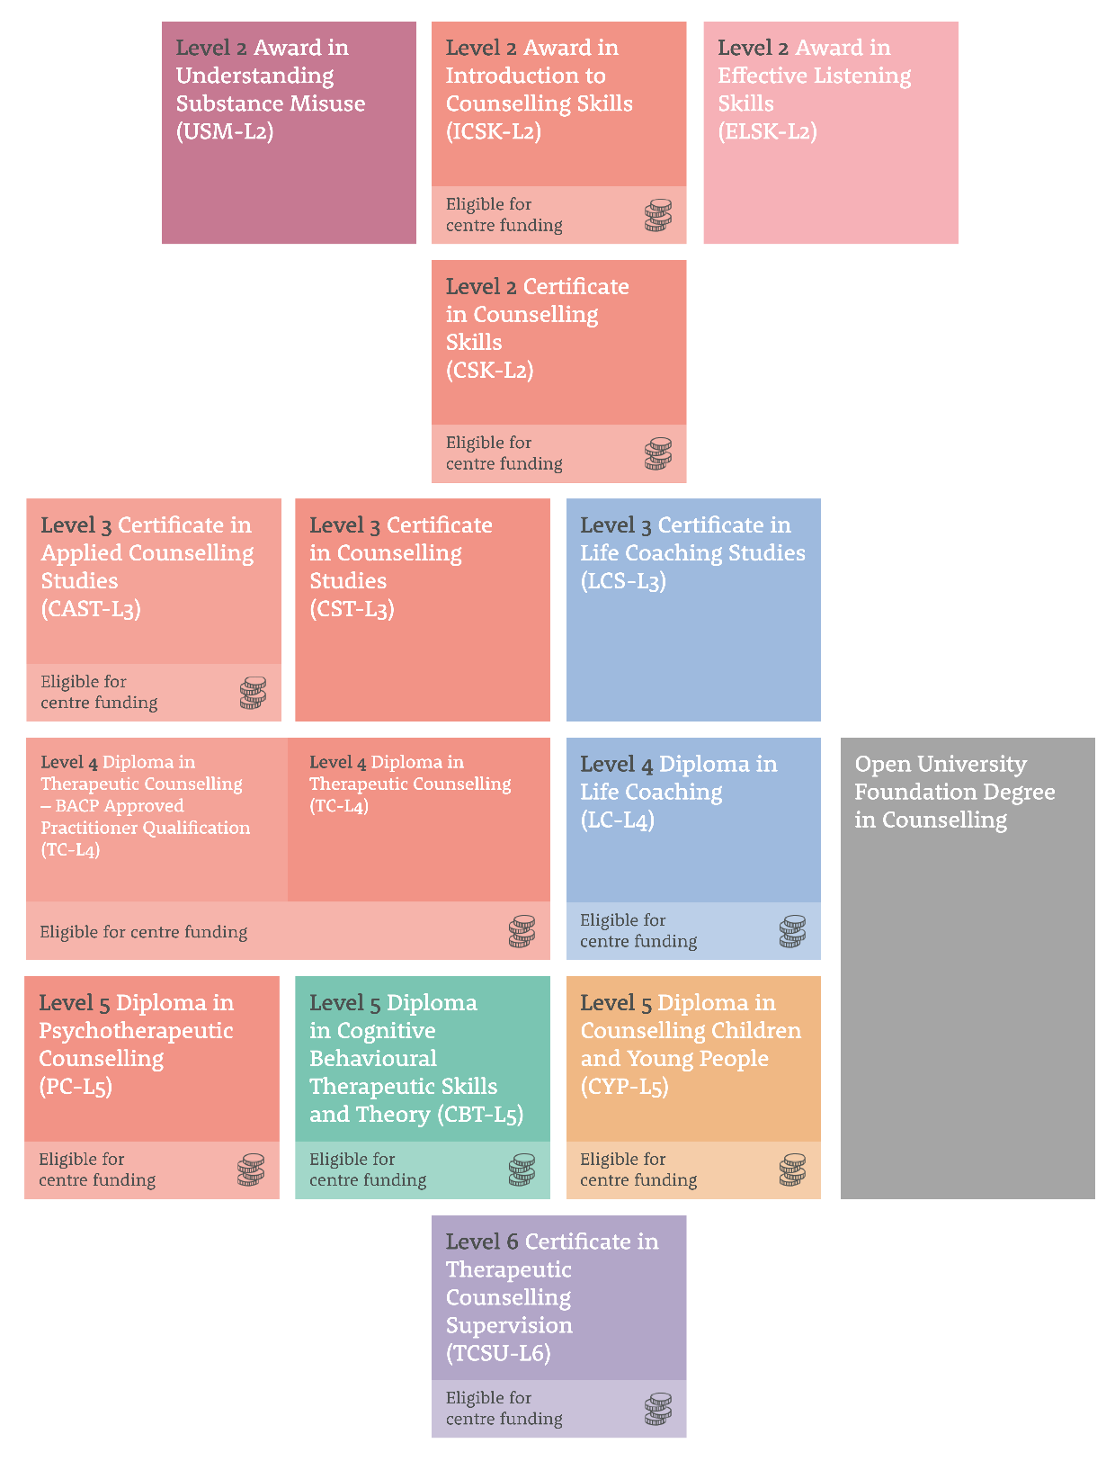

Equivalent to European Qualification Framework (EQF) level 5 and Scottish Credit Qualification Framework (SCQF) level 8.
This age requirement is linked to Ofqual’s system for categorising qualifications.
CPCAB recommends a minimum of 450 practice hours in line with BACP individual accreditation requirements.
Candidates wishing to apply to UKCP for registration as a psychotherapeutic counsellor should be aware that the minimum requirement for personal counselling is 105 hours and at least 50 hours must be undertaken during training. See CPCAB website for further information.
CPCAB recommends that candidates access appropriate clinical supervision to meet the requirements of their chosen ethical framework or professional membership association. For example, BACP Supervision Guidelines for trainees require a minimum of 1½ hours individual supervision per month (or the equivalent if in group supervision) or 1 hour of supervision for every 8 hours of client work.
This is in line with BACP counsellor individual accreditation requirements
Contact the Open University or your chosen HE institution directly to discuss credit transfer options. This qualification, alongside CBT-L5, can be used as a 60-credit exemption for module D241 (Exploring Mental Health and Counselling) on Stage 2 of the Open University BSc (Hons) Counselling.
In order for your application to be processed the approval fee will need to accompany your application. This is non-refundable. Payment can be made by cheque payable to CPCAB or via Bacs payment. Please contact finance@cpcab.co.uk for more information.
All centre-designed courses must be approved by CPCAB before candidates can be registered. Although the delivery of courses may differ from centre to centre, all delivery must enable the candidates to achieve the learning outcomes of the qualification.
Proforma and guide sheets for internal assessment can be downloaded from the CPCAB Website.
This is an on-going review of learning during the course (also called a learning journal).
CPCAB recommends that the candidate’s agency provides appropriate clinical supervision to meet the requirements of their chosen ethical framework or professional membership association. For example, BACP Supervision Guidelines for trainees require a minimum of 1½ hours individual supervision per month (or the equivalent if in group supervision) or 1 hour of supervision for every 8 hours of client work.
Self-review of learning, progress, and completion of the learning tasks (criteria). Template available on the CPCAB website.
This can include hours undertaken prior to the start of the course, but at least 10 hours must be during the course.

